Community Engagement Manager Report
6 Month Review March-August

Contract name- Community Engagement – Wiltshire

Community Engagement Manager Role

The CEM shall produce monthly reports, with photos, on the performance of the services in this contract in an approved format (in compliance with the Public Body Accessibility Regulations 2018) to allow publishing on the council’s website.

The CEM shall produce a three-monthly schedule of services for the council to share information and illustrate the good works via its Twitter feed and Facebook social media channels. On a weekly basis, different topics with photos highlighting special activities will be issued to the council for publishing.

The CEM will produce a weekly draft press release on different subjects in this contract to promote good works and public engagement.

On an ongoing basis, the contractor shall provide loan equipment and undertake the collection of bagged waste from community events undertaken on Wiltshire Council land. The council expects the loan equipment to be held in the 3 depots:

• 50 litter pickers
• 50 litter picking hoops
• Gloves
• Bags – appropriate number
• Branded Hi-Viz Class 3 vests

The CEM shall provide an email and contact number for event organisers to use, with the provision and collection all being undertaken by the contractor. This is to be linked with the promotion and communication.
Each year the CEM will be expected to increase the number of community litter picking loan equipment opportunities, by promoting the scheme and engaging the local community. Historically the council has offered 52 activities each year, this will be the baseline.

Further information with regards to the CEM objectives can be found in the idverde Business Plan Social objectives.

Brief report
- Great British Spring Clean and Great Big School Clean 2023.
- We started off the year with Great British Spring Clean and Great Big School Clean 2023 which took place from 17 March to 2 April, back for its eighth year, the Great British Spring Clean is the nation’s biggest mass-action environmental campaign.
- Number of collections completed during the above period 42 number.
- Total number of bags collected 392 number.
- Total number of 2352 kg.
- Total number of volunteer hours 420.

Fit for a King
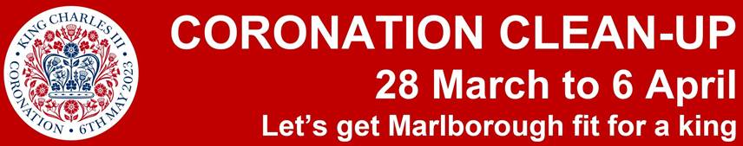

- In the lead up to King Charles III’s Coronation, Marlborough Town Council has launched its own ‘Coronation Clean Up’ campaign which idverde in partnership with Wiltshire Council helped to support, by providing both labour resources and machinery on the 28th March and 4th April.
- idverde in partnership with Wiltshire Council supported the event as detailed below
- Number of collections completed during the above period 19 number.
- Total number of bags collected 243 number.
- Total number of 1458 kg.
- Total number of volunteer hours 190.

Litter collection carried out by Parish Councils and Community Groups that idverde have supported 2023- 2024

Proposed for 2023/2024
- Proposed collections 52 number.
- Estimated number of bags collected 596 number.
- Estimated number of KG 4278 kg.
- Estimated number of volunteer hours 970.

Actual for March – August 2023
- Number of collections completed during the above period 97 number.
- Total number of bags collected 1270 number.
- Total number of 7620kg.
- Total number of volunteer hours 970.

Community groups volunteers supplied 970 hours of free labour
- Tracking at 123 litter collections as of 30th August 2023.
- Total requests for loan of equipment to date 36 as of the 30th August 2023.
- We are working with or are in communication with 82 Parish Councils.
- We are working with 23 Community groups on a regular basis.

Community litter picking groups
The following Community Groups have completed 1 no litter collection per month over the last 6 months.
- Rudloe Womble Litter Pick 1st Sunday of each month.
- Jubilee Meadow Clearance group 2nd Saturday of each month.
- Paxcroft Community Group 2nd Saturday of the month.
- Calne Clean-up Crew a member of the group emails when they require bags to be collected as agreed with Wiltshire Council.

Monthly litter collections for Parish Councils & Community Groups

Month | Kg | Bags | Collections | Number of Volunteer hours
March | 6730 | 673 | 38 | 380
April | 3590 | 359 | 26 | 260
May | 1280 | 128 | 14 | 140
June | 330 | 33 | 9 | 90
July | 580 | 58 | 6 | 60
August | 190 | 19 | 4 | 40
September | 0 | 0 | 0 | 0
October | 0 | 0 | 0 | 0
November | 0 | 0 | 0 | 0
December | 0 | 0 | 0 | 0
January | 0 | 0 | 0 | 0
February | 0 | 0 | 0 | 0
Total | 12700 | 1270 | 97 | 970

idverde Community Fund
The following groups have benefited/allocated from the above fund.
- Men’s Shed Trowbridge
- Grow Food Not Grass, Bemerton Heath, Salisbury
- Box Hill Community Group
- Wiltshire Wildlife Trust

The following press releases have been sent, for Wiltshire Council Social Media sites (to David Perret and or Jack Holdaway)
- Bedwyn Footpaths Group
- Great British Spring Clean 2023
- Everleigh Spring Litter Pick
- Woodbrough litter collection
- Steeple Langford Parish Great British Spring Clean - 11 March 2023
- A day in the life of Gary Dougherty, who is a qualified Outdoor Operational Playground Inspector
- Litter Pick in Kington St Michael
- Dilton Marsh litter pick - April 2023
- Transport Day at Step Ahead Nursery Trowbridge
- St John’s Catholic School litter collection
- idverde to support Wiltshire Council in ‘Wiltshire Fit for the King Litter Pick’
- Rudloe Womble - Great British Spring Clean
- Old Sarum & Longhedge Litter Awareness Campaign
- Litter collection at Meiyume
- Men’s Shed Trowbridge
- Community club meeting at Norfolk Road with idverde’s Community Engagement Manager Paul

Example of an article produced for the CEM weekly report supplied to Wiltshire Council

- Photos: Litter collection completed week ending 1st and 2nd April
- Kington St Michael “The Great British Spring Clean”
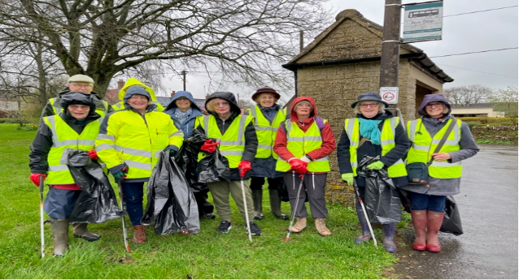
We had a productive but wet morning on Saturday. The bags are behind the bus shelter on the Ridings in Kington St Michael SN14 6JG. Hopefully they can be picked up on Monday (3rd April). My team reported that there was some fly-tipping of car parts along the road to the motorway on the left hand side just over a small bridge. We have left these insitu as they were too heavy to move. “Members of Kington St Michael WI” with assistance from the Down Gospel Trust braved the elements to collect litter through and particularly at either end of the village. Here’s hoping the Kington St Michael can remain litter free for the forthcoming Coronation celebration”

Thank you Paul for your assistance and the equipment will be returned to Churchfields on Monday

Ongoing project/links
- Men’s Shed Trowbridge
- St John’s Catholic School Trowbridge
- Grow Food Not Grass, Bemerton Heath Salisbury
- Bath Rugby Farleigh House
- Box Hill Community Group
- Wiltshire Wildlife Trust
- Youth Justice Service Wiltshire
- North Bradley Peace Memorial Trust (Charity)
- Lackham College
- International Green Keepers
- Chiesi Ltd, Chippenham
- Meiyume Ltd Westbury

In supporting Wiltshire Wildlife (Proposed)

Traineeships (Apprenticeships), idverde will be at the forefront of conservation delivery at popular Trowbridge Nature Reserves. idverde will be providing the foundation that supports the prioritisation of our natural spaces for biodiversity and sustainability, as well as inclusion and engagement for individuals, communities, and wildlife.

With the support of Wiltshire Council, idverde’s support of Wiltshire Wildlife Trust Traineeships can deliver excellent opportunities for positive communications and an enhancing of reputation, delivering positive messaging through social media channels and the press.

The further resource that Trainees offers, will enable us to maintain popular local nature reserves at Green Lane Wood and Biss Wood. Over 3000 people visit the woods each month, with lots of different groups, including local schools and walkers, partaking in projects and community tasks, such as Get Wiltshire Walking (a Wiltshire Council funded project).

Trainees will qualify in the use a chainsaw, meaning that our Estates Teams have the necessary resource to carry out essential works safely and efficiently; without Trainees, works can be delayed or overly reliant on volunteers.
Trainees are given practical support and advice, to learn independence, specific skills, confidence and to develop their own passions throughout the conservation and ecological projects they get to work on.
Any Tranees go on from these roles into careers in the environmental and ecological sector. The impact of idverde’s support of these Trainees will be significant, as they go on to further their work in bringing communities and natural spaces together for the benefit of wildlife and people.

Supplied bird boxes to the following Community Groups/schools
- All Canning Primary School x 1
- Castlemead Primary school x 1
- Box Hill Community Group x 2
- Sheltered Housing, Norfolk Road and Philips Court, Salisbury x2
- Katherine Park, Corsham. x 2
- St Nicholas Primary School Brohmam x 1
- Lavington Pre-School x 1

Box Hill Lower Common restoration

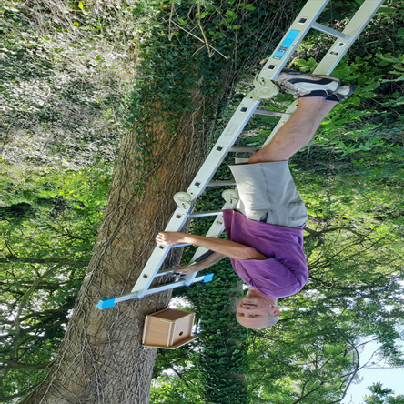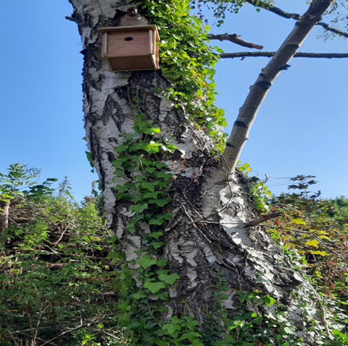

As part of our own ongoing work to restore the Box Hill Lower Common to a limestone grassland, the community team had another work party. This includes installing 2 bird boxes which were kindly provided by idverde working in partnership with Wiltshire Council. The boxes, the first on the lower common, were fitted to a Silver Birch and Ash tree and look great. The team also scythed one area of grassland in an effort to collect some wildflower seeds for spreading in other areas of the common.

We have 10 bug hotels
- These are to be allocated on a first come basis when schools return in September.

Daffodils bulbs
We have purchased 250 kg of bulbs to be allocated to Parish Councils, Community Groups and schools on a first come basis (10kg bags)
- Corsham open space (freestone)
- North Bradley Peace Memorial Trust (Charity)
- All Canning School
- Box Hill Lower Common
- St Nicholas VC Primary
- Norfolk Road Community Club meeting
- Phillip Court Community Club meeting
- Lavington Pre-School

idverde have/will be supporting the following event in 2023
- Wiltshire Council Highways and Transport Career Fair 16th August 2023
- Society of Local Council Clerks (SLCC) 15th September 2023.

idverde attended the Wiltshire Highways and Transport Career Fair hosted by Wiltshire Council

The intention was for the council, its contractors, and suppliers to meet each other. Allowing idverde to meet with local people who were able to learn more about the exciting career opportunities available in Wiltshire's essential Highways and Transport services.
To date, we have had 2 completed application forms back from clients from the Wiltshire Employment Support Team & Supported Internships Employment & Community Skills.
We have also arranged further meetings with Wiltshire Council Armed Forces Network who made contact during the fair.

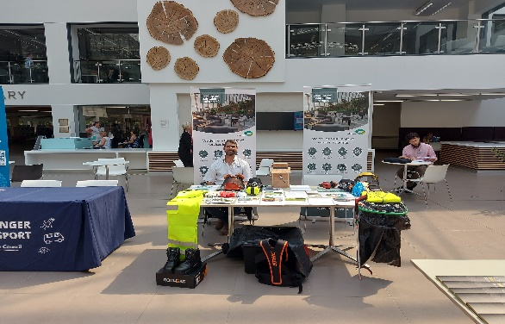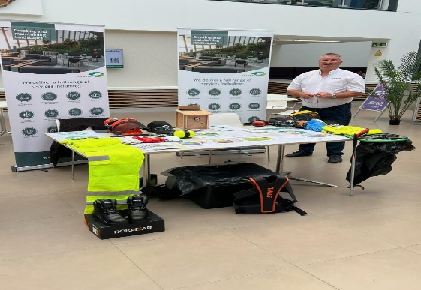

idverde Charity for 2023

June’s recent trip to Greece to support Vaso Animal Shelter

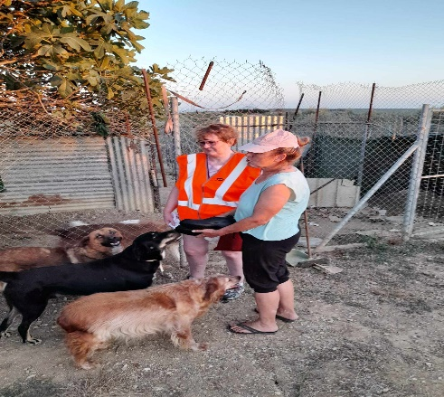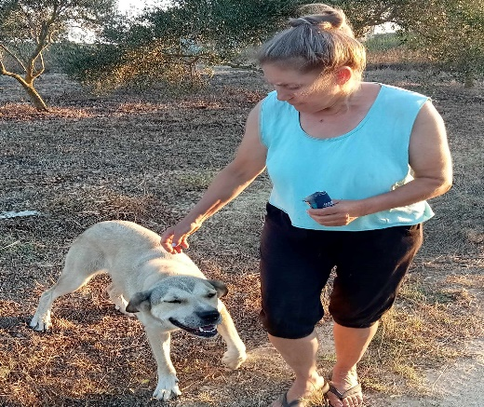

They say that under the greatest adversity, there exists the greatest potential for doing good, for oneself and others. June Cooke- Contract Administrator (Wiltshire) is living this out in real time, calling for support of Vaso Animal Shelter located in Gargalianoi Messinia, Greece. With over one million stray cats and dogs, Greece has no funded animal shelters, leaving many unwanted animals at the hands of private citizens like Vaso Animal Shelter owner, Vaso Aggelopoulou. For over 20 years, Vaso has dedicated her life to rescuing over 65 dogs and 30 cats at the shelter, but now, finds herself facing her own battle with cancer.
June will have travelled to Greece this August, to help out at the shelter while Vaso receives the necessary medical care she requires.
As the shelter relies on the generosity of others through donations, There is a GoFundMe page to raise funds for Vaso and ensure the shelter can be properly maintained during her treatment.

idverde to attend community club meeting at Norfolk Road and Philip Court

- Kate Darbyshire Senior Resident Engagement Officer for Wiltshire asked if idverde would be willing to attend Norfolk Road and Philip Court community club meeting in the month of August.

Today's community club meeting at Norfolk Road with idverde Community Engagement Manager Paul

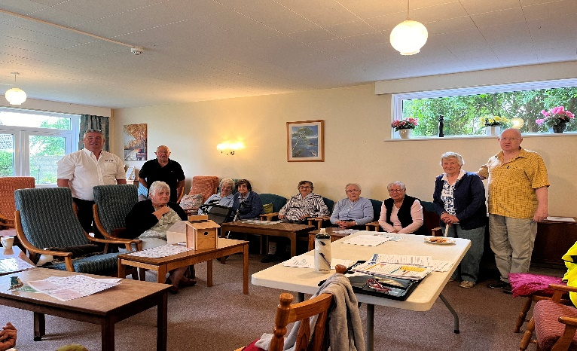

Paul, it was super to have you come along to our community club meeting at Norfolk Road today. Our customers really enjoyed your talk and are delighted with the bird box and bird identification charts. Thank you so much!

We look forward to seeing you at our November meeting to plant the daffodil bulbs!
Residents at our Norfolk and Suffolk Road sheltered schemes were in for a treat at their monthly community club meeting hosted by their Resident Engagement Officer this summer. Attendees had the chance to meet Community Engagement Manager Paul from idverde who gave a talk on the work he is undertaking in the county including work involving nature, birds and bugs. Paul provided identification charts showing 20 of the most common British garden birds for residents to take home and use at their leisure and even provided a bird box to install in the Norfolk Road communal garden. Residents have invited Paul to join their November community club meeting and will look forward to it greatly as he will be providing daffodil bulbs for the group to plant not to mention their very own bug hotel!

Philip Court clearance of planters in the entrance way

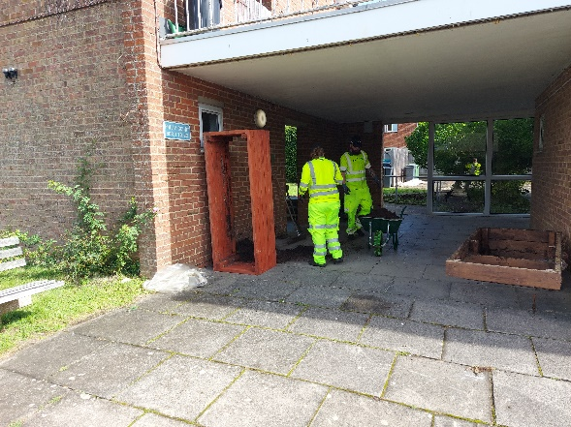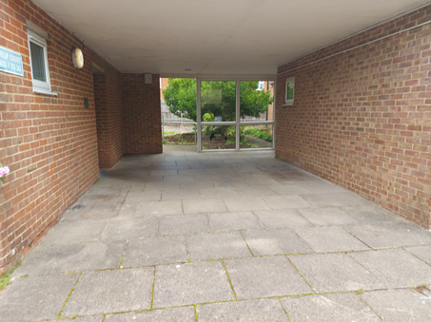

Community Engagement Manager attended Philp Court for the second community club meetings and delivered a talk on the CEM work including nature, bird identification cards (more to follow) for tenants, the gifting of a bird box which the CEM will install in due course with tenants. The CEM will be attending our November Community Club meeting and will bring daffodil bulbs that can be planted in the border along the left-hand gable end boundary where tenants plan to plant wildflower seeds as part of SIB application.
REO organising a community clear up day with tenants with the CEM / idverde to carry out the re location of the unwanted planters in the entrance area. One of the planters will be used to create a bug hotel in the communal garden and the other one will be used to create an herb garden.
REO, Following the above talk Kate Darbyshire organised a community clear up day with the CEM for the 24th August, Kerry Hurst and David Rogers of idverde carried out the re location of the unwanted planter/compost in the entrance area.

Positive Feedback: Box Parish Council/ Rudloe Wombles
Hi Martin,
Could you pass on thanks to Paul Ashman and his team in idverde – see below
We really need to pass positive feedback to these teams as they have a difficult job keeping everyone happy

Regards
Derek
Cllr Derek Walters

Hi Craig,
I think this one is probably one for you, rather than us in waste services?
Please could you pass on the thanks for Cllr Walters and others to Paul Ashman at idverde.
Thanks
Martin
Head of Waste Management
Environment

CEM list of event/publication for 2024
Promotional material is to be supplied by idverde.
- Hedgehog awareness week
- Top 10 beginners trees
- Great British Spring Clean
- Bird watch
- Butterfly Conservation
- Wildflower meadows
- Top 10 beginners trees
- Common UK insect identification

